**Where’s da Beef?**

**Background**

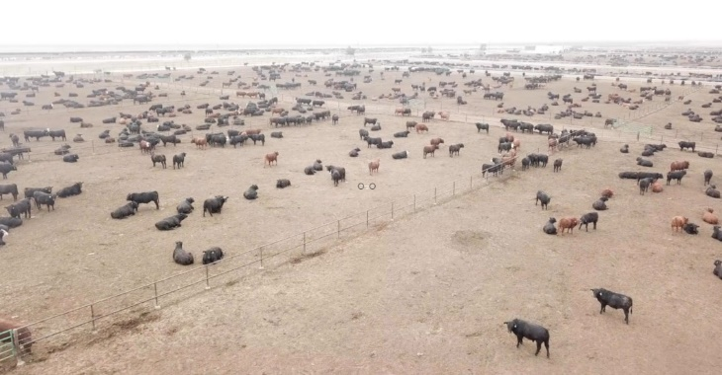You are part of the financial reporting team for an agricultural company called Where’s Da Beef (WDB) Cattle Feeders. WDB Cattle Feeders is a cattle feed yard in southern Kansas. Cattle from all around the country are transported to WDB when they are approximately six months old to receive the nutrition and food they need to gain weight efficiently to prepare for human consumption. Cattle remain at WDB for approximately 190 to 270 days, during which time they typically gain approximately 800 to 1,200 pounds. WDB then sells the cattle to beef slaughter and packing companies.

WDB spans an area of 1.5 square miles and contains approximately 440 pens (i.e., a designated area where cattle are fenced), each of which can contain anywhere between 0 to 200 head of cattle at any given time.

**Accounting for Inventory at Where’s da Beef**

WDB performs a physical inventory count at the end of each year to ensure the accuracy of the company’s inventory records. The physical counts are compared to the inventory records maintained by WDB as of December 31, WDB’s fiscal year-end.

You are interested in making the annual physical inventory count less time-consuming and less stressful for the cattle. To that end, you developed and proposed an idea to perform this year’s count of cattle with drone technology and automated counting software, and your manager agreed with your proposal. As such, this year’s count of inventory was performed with drone technology and automated counting software.

**Overview of Counting Process**

* Watch the video at this link for an overview of WDB’s traditional method for counting inventory and how drones and automated counting technology might improve that process: <https://mp126803.cdn.mediaplatform.com/126803/wc/mp/4000/7319/98474/104500/Lobby/default.htm>

**Accounting for Inventory in Pen 231**

To illustrate how drone technology and automated counting software can be used to count inventory at WDB, let’s focus on just one of WDB’s pens—Pen 231.

* *Original Purchase of Cattle for Pen 231.* On June 1, 2022, WDB purchased 120 cattle from a supplier for $73,600 on account. These cattle were moved to Pen 231. No other cattle occupy this pen. Note that WDB treats cattle as inventory, since cattle are held for sale to customers.
* *Drone image of Pen 231.* On January 1, 2023, your team produced the following drone image of Pen 231:

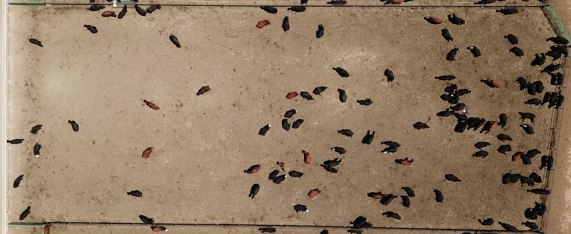

* *Automated Counting Software for Pen 231.* On January 1, 2023, your team submitted the drone image to an automated counting software application, which produced the following image and count for your records. As seen in the top right of the image below, the automated counting software counted the cattle in Pen 231.

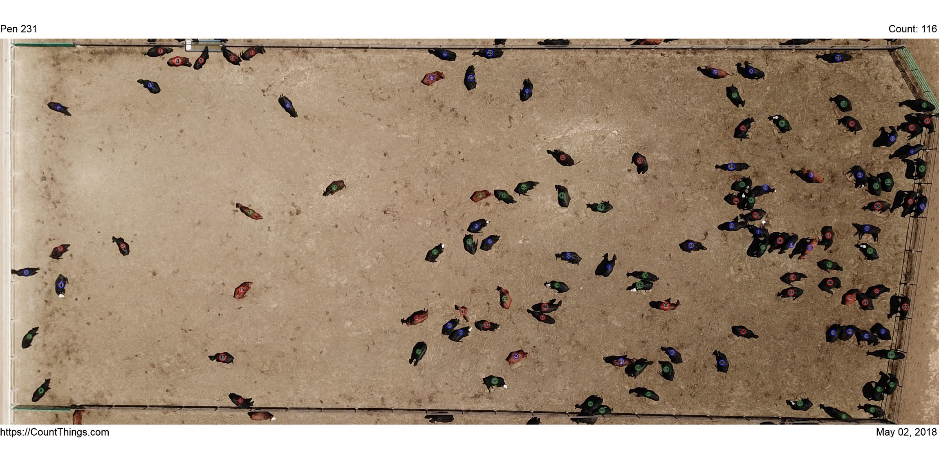

**Module quiz question.** Note your answer to this question, as it will be included in the module 14 quiz.

Which of the following is the best conclusion derived from the drone images?

a. The inventory account does not need to be adjusted.

b. The inventory account is understated and needs to be adjusted up to reflect an increase of four cattle.

c. The inventory account is overstated and needs to be adjusted down to reflect a decrease of four cattle.